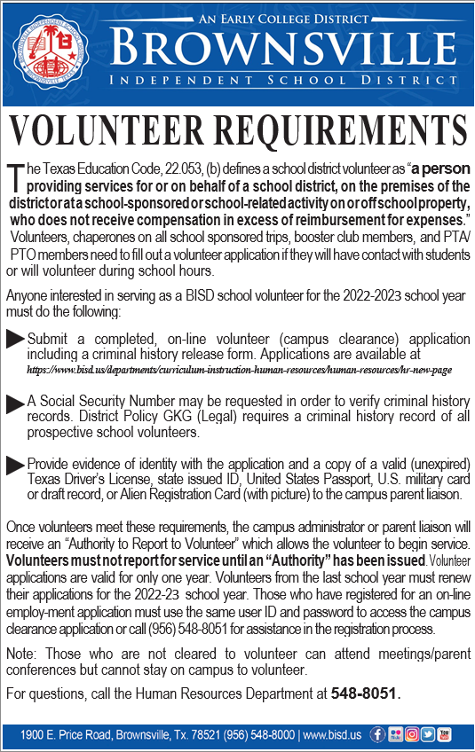

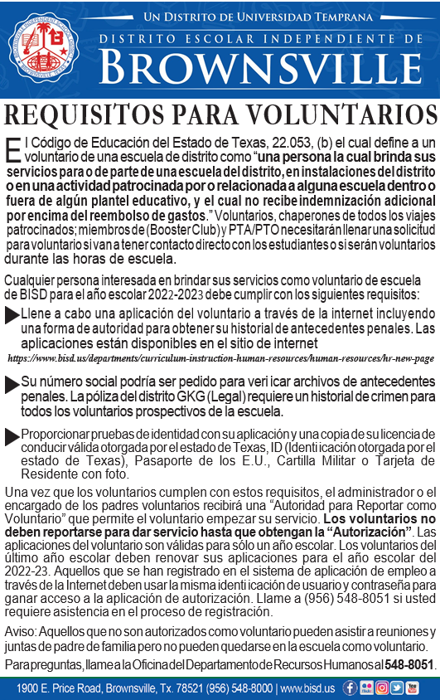

CAMPUS VOLUNTEER APPLICATION
“CAMPUS CLEARANCE”
Go to www.bisd.us
Click on Departments
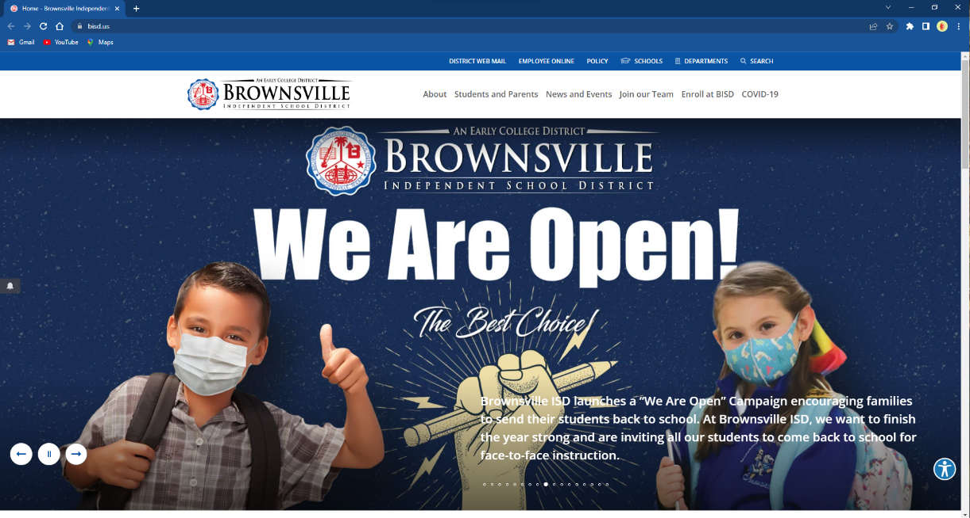
Departments

Click on Human Resources
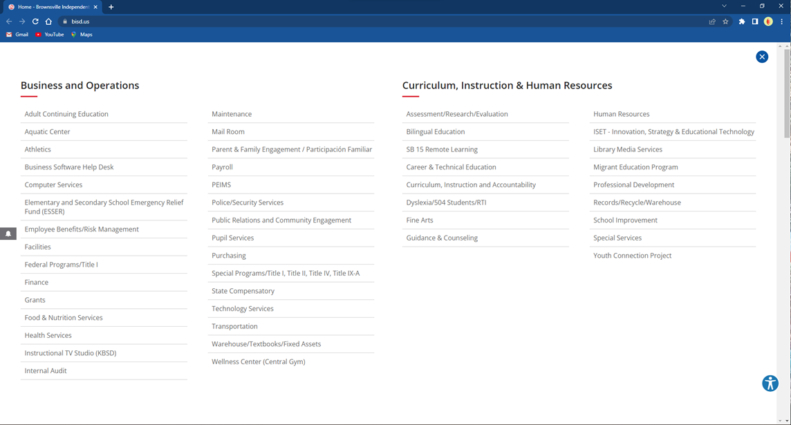
Human Resources

Click on Campus Clearance
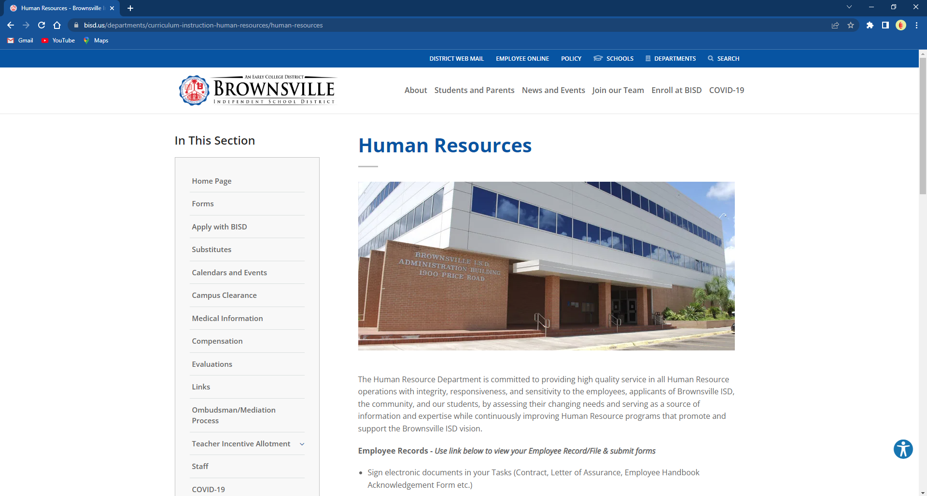
Campus Clearance

Click on Campus Clearance Application
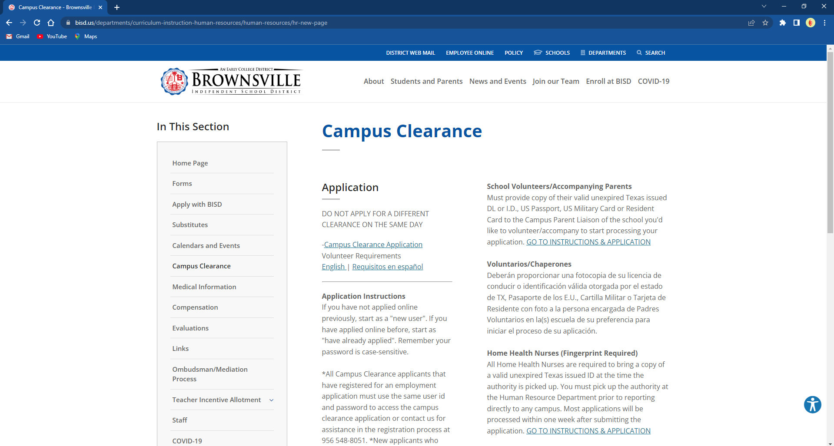
Campus Clearance Application
On the Search Box type in Campus Volunteer
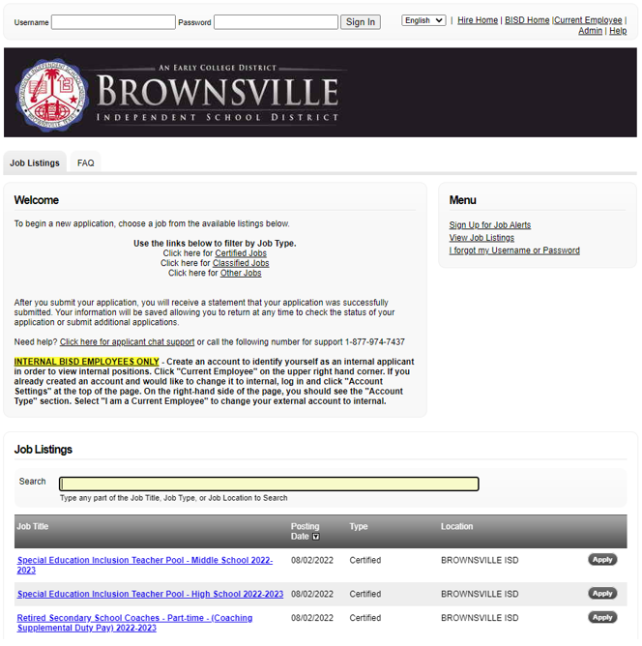

Click on the Apply Button
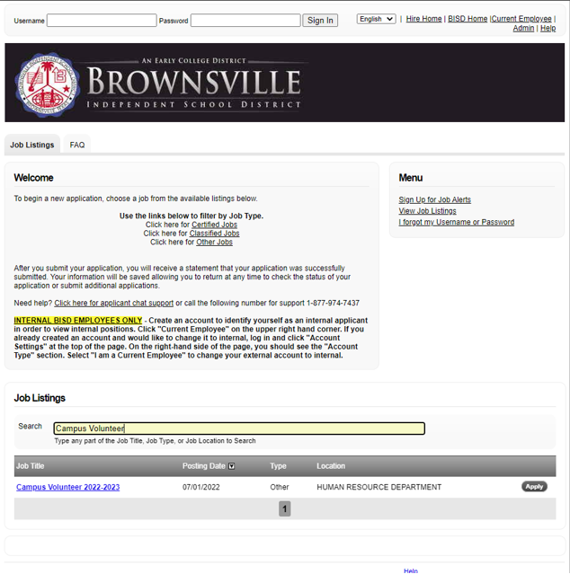
Campus Volunteer
Click on Apply for this Position
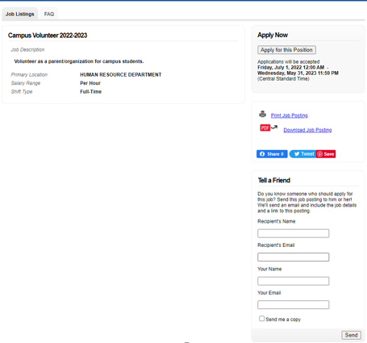

If you have never applied before go to the Create New Account and Apply
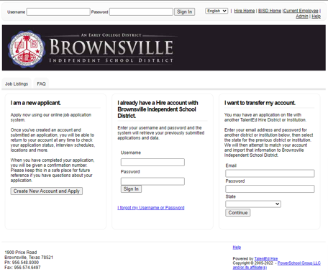

LAST STEP:
After you submit your application to Volunteer:
- Report to the campus or department you applied for and the Parent Liaison/Office Staff will make a copy of your ID/License to submit to Human Resources along with the Campus Clearance Approval slip signed by the Campus Principal.

- The background check will be conducted and the Campus Parent Liaison will be sent a copy of your Authority to Volunteer form if approved.

Thank you for your interest in Volunteering in BISD!

